Year end open transfer variance report…

Falcon

T- Transfers

R-Transfer Reports

R-Transfer Variance Reports

I run loc separate

System

To Whs =

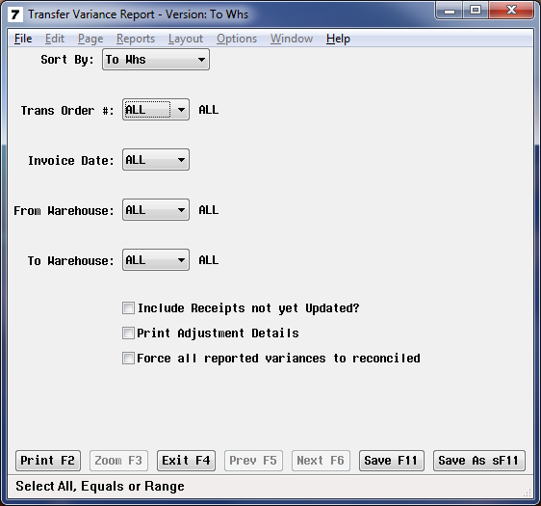

Save to file

Open Excel

G Drive

All files

Find report

Turn into an excel file

Rec open transfers

Send detail of transferred rec to rec manager and store manager.